**ONLINE BANKING SYSTEM**

PROJECT REPORT

By

**RAVURU SAI VIKAS(RA2311056010057)**

**KUPPAM DENETH KUYMAR (RA2311056010056)**

Under the guidance of   
**Dr. D Hemavathi**

*in partial fulfilment for the Course*

of

**21CSC205P-Database Management Systems** In the Department of Computational Intelligence



**FACULTY OF ENGINEERING AND TECHNOLOGY**

**SCHOOL OF COMPUTING**

**SRM INSTITUTE OF SCIENCE AND TECHNOLOGY**

**KATTANKULATHUR**

**SRM INSTITUTE OF SCIENCE AND TECHNOLOGY**

**(Under Section 3 of UGC Act, 1956)**

**BONAFIDE CERTIFICATE**

Certified that this project report for the course **21CSC205P – Database Management Systems** entitled in **“Online banking system”**

is the bonafide work of **RAVURU SAI VIKAS (RA2311056010057)** and of **KUPPAM DENTH KUMAR (RA2311056010056)** who carried out the work under my supervision.

# SIGNATURE SIGNATURE

Dr. D Hemavathi  Dr Kavitha V

# Course Faculty Head of the Department

Associate professorProfessor

Department of DSBS Department of DSBS

SRM Institute of Science and Technology SRM Institute of Science and

Technology

Kattankulathur Kattankulathur

# ABSTRACT

Online banking system is a secure and interactive web-based platform designed to help users manage their financial transactions with ease. Developed using XAMPP, PHP, HTML, CSS, and JavaScript, this system ensures a seamless and efficient user experience, offering a robust solution for everyday banking needs.

**Key Features Include:**

* User Login/Authentication: Users can securely log in using their unique credentials, ensuring data privacy and protection. The login system uses secure hashing techniques for passwords, enhancing security.
* Account Management: Once logged in, users can easily manage their bank accounts, view balances, and monitor recent transactions. The system supports multiple accounts, allowing for effective financial management.
* Money Transfers: Users can send and receive funds, both domestically and internationally, with real-time tracking of transfer statuses.
* Bill Payments: The system allows users to securely pay bills, such as utilities and subscriptions, directly from their accounts.
* Transaction History: Users can access a detailed history of their transactions, including date, amount, recipient, and transaction type.
* Secure Payment Gateway: Built with high security standards, the platform integrates a secure payment gateway, ensuring all online payments, transfers, and bill payments are protected.
* Account Settings: Users can update personal information, change passwords, and configure notification preferences from their personalized account dashboard.
* Responsive Interface: Designed with HTML, CSS, and JavaScript, the platform ensures a clean, responsive design that works seamlessly across all devices, including desktops, tablets, and smartphones.
* Transaction Alerts: Users can enable real-time notifications for account activity, including incoming transfers, bill payments, and low balances.

**TABLE OF CONTENTS**

|  |  |  |  |
| --- | --- | --- | --- |
| **SR NO.** | | **CONTENTS** | **PAGE NO** |
| **1** | **INTRODUCTION** | |  |
|  | 1.1 MOTIVATION | | **5** |
|  | 1.2 OBJECTIVE | | **5** |
|  | 1.3 PROBLEM STATEMENT | | **6** |
|  | 1.4 CHALLENEGES | | **6** |
| **2** | **REQUIREMENTS** | |  |
|  | 2.1 REQUIREMENT ANALYSIS | | **7** |
|  | 2.2 HARDWARE REQUIREMENT | | **8** |
|  | 2.3 SOFTWARE REQUIREMENT | | **8** |
| **3** | **ARCHITECTURE AND DESIGN** | | **9** |
| **4** | **ER- DIAGRAM** | | **10** |
| **5** | **CONCLUSION** | | **11** |

**INTRODUCTION**

In today’s fast-paced digital world, managing financial transactions online has become a necessity for both individuals and businesses. Traditional banking systems often struggle with issues such as slow processing times, limited accessibility, and security concerns. The **online banking system** is designed to overcome these challenges by offering a secure, efficient, and accessible online banking platform. With real-time transaction tracking, enhanced security features, and a user-friendly interface, Click Banker provides a comprehensive solution for managing financial operations seamlessly and securely.

* 1. **Motivation**

In today's fast-paced world, financial management and transactions require a high degree of security, efficiency, and accessibility. Traditional banking methods often fail to meet the demands of users seeking seamless, real-time financial services. The **online banking system** is designed to address these shortcomings by offering a secure, interactive, and easy-to-use platform for managing various financial transactions. This platform aims to make everyday banking services such as account management, money transfers, bill payments, and transaction tracking more efficient and user-friendly.

* 1. **Objective**

The primary objective of the **online banking system** is to provide comprehensive, secure, and interactive online banking platform that caters to users’ financial needs. The platform will:

* Provide secure account management with real-time updates on balances and transactions.
* Enable users to transfer funds domestically and internationally in a secure manner.
* Allow for bill payments directly from bank accounts, with real-time payment confirmations.
* Offer an intuitive, responsive interface that works across devices (laptops, smartphones, and tablets).
* Ensure data privacy and security through encrypted communications and secure payment gateways.
* Provide transaction history, alerts, and account settings management to improve overall user experience.
  1. **Problem Statement**

Traditional banking systems, though functional, present several challenges:

* **Security Risks:** Unauthorized access, fraud, and data breaches remain common issues in banking platforms.
* **Limited User Interaction:** Many current platforms lack interactive and intuitive features, making financial management cumbersome for users.
* **Inefficient Transactions:** Slow and unreliable payment processing, especially for international transactions, reduces the efficiency of banking services.
* **Lack of Real-Time Updates:** In many cases, transaction statuses and account information updates are not immediate, leaving users unsure of their financial status. To address these challenges, the **online banking system** provide a streamlined, secure, and real-time financial management experience.
  1. **Challenges**

The development of the **online banking system** faces several key challenges:

* **Security and Privacy:** Ensuring that user data and financial transactions are protected against fraud and hacking.
* **Real-Time Data Processing:** Maintaining the accuracy of transaction updates and account balances in real-time, especially with high volumes of users.
* **User Experience:** Developing a user interface that is both functional and intuitive to cater to users with varying levels of technical knowledge.
* **System Scalability:** Ensuring that the platform can handle a growing number of users and transactions without performance degradation.
* **Compliance:** Ensuring the system adheres to regulatory standards, including GDPR and PCI DSS for financial transactions.

**REQUIREMENTS**

The successful development and deployment of EstateEase require a structured analysis of system needs, along with appropriate hardware and software resources.

**2.1 Requirement Analysis**

**The online banking system** **is designed to provide users with efficient financial transaction management. The key requirements include:**

* **Account Management: Users must be able to view balances, transaction history, and manage multiple accounts (checking, savings, etc.).**
* **Money Transfer: Secure transfer of funds, both domestically and internationally, with real-time tracking of status.**
* **Bill Payment System: A secure and easy way for users to pay utility bills, subscriptions, and other payments directly from their bank accounts.**
* **Transaction History: Users must have access to detailed records of their transactions with search and filter capabilities.**
* **Secure Payment Gateway: Integration with payment providers (e.g., Stripe, PayPal) to ensure safe online transactions.**
* **Real-Time Notifications: Users should receive real-time updates on transaction activity, account balances, and alerts.**
* **Responsive User Interface: The platform must be responsive, providing an optimal experience across devices (desktop, tablet, mobile).**

**2.2 Hardware Requirements**

For optimal performance, the following hardware specifications are needed:

* **Development & Deployment System:**
  + **Operating System:** Windows 10/11 (or any OS compatible with XAMPP)
  + **Processor:** Intel Core i5 or higher
  + **RAM:** Minimum 8GB (16GB recommended for better efficiency)
  + **Storage:** 256GB SSD minimum (500GB recommended for large-scale deployment)
* **End-User Requirements:**
  + **Device:** Laptop, Desktop, Tablet, Smartphone
  + **Processor:** Dual-Core or higher
  + **RAM:** Minimum 4GB
  + **Storage:** At least 10GB free space
  + **Browser:** Google Chrome, Mozilla Firefox, Safari, or Edge
  + **Internet:** A stable broadband connection

**2.3 Software Requirements**

• **Frontend (Client-Side Development):**

* **Languages:** HTML, CSS, JavaScript
* **Frameworks/Libraries:** Bootstrap, React.js / Angular.js
* **Development Environment:** Visual Studio Code, Sublime Text

• **Backend (Server-Side Development):**

* **Programming Language:** PHP
* **Database:** MySQL (for storing user data, transactions, accounts, bill payments)
* **Web Server:** Apache (XAMPP)
* **Browser Compatibility:** Supports Google Chrome, Mozilla Firefox, and other modern browsers

**ARCHITECTURE AND DESIGN**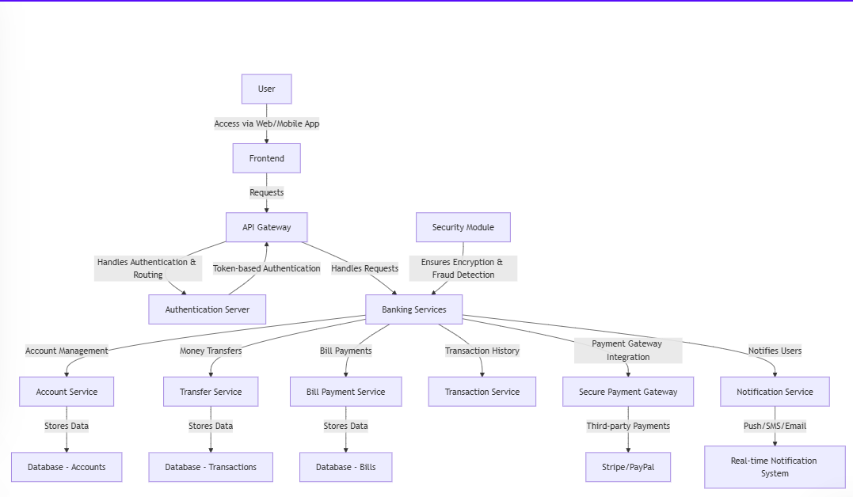

**ER- DIAGRAM**

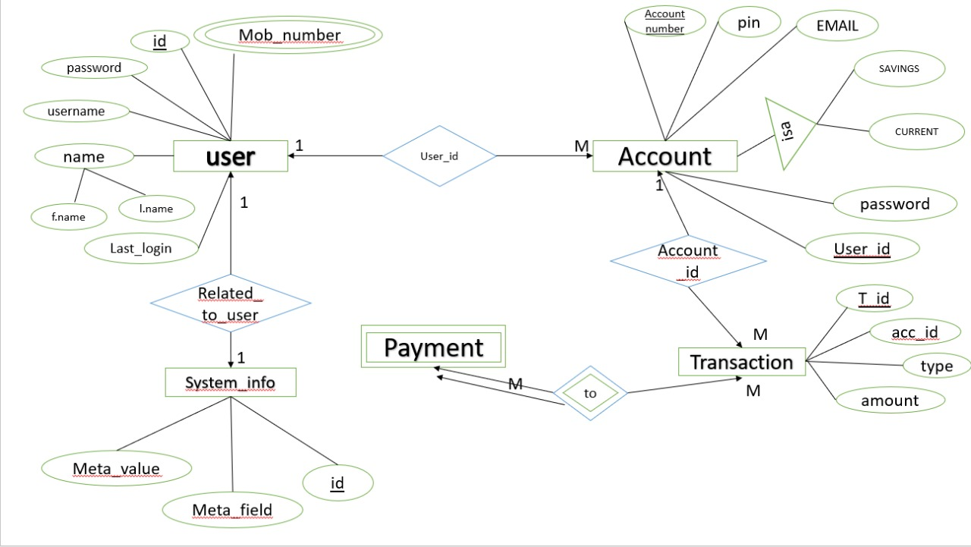

**CONCLUSION**

The **online banking system** aims to revolutionize the way users manage their finances by providing a secure, user-friendly, and scalable platform. By integrating real-time transaction tracking, secure payment gateways, and an intuitive interface, the system addresses key challenges in current banking platforms. As the system grows, it will adapt to increasing user demands and maintain the highest standards of security and efficiency. This project will significantly improve how users interact with their finances, providing them with a seamless and secure banking experience.